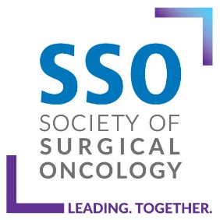 | Breast Fellowship Complement Increase/Decrease Form

Please submit this form to fellowship@surgonc.org for review at one of the quarterly Training Committee meetings. Please submit a block diagram of the new proposed complement and case logs (institutional or if an unaccredited fellow is present). If you have any questions, please email fellowship@surgonc.org

PROGRAM INFORMATION
Program Name: |  | Date:

Program Director Name:
 | Last | First | M.I.
Program Coordinator:
 | Last | First | M.I.

Email:

☐ | Complement Increase | ☐ | Complement Decrease |  | Current # of Approved Fellowship Positions

Positions Requested

Rationale for request:
Additional Comments:
Program Director Signature | Date

